Work - Worksheet 1

- Calculate the work done on an object by a force of 5.7 N pushing an object 2.3 m.

- Calculate the distance an object is moved when a force of 27.2 N creates 86.2 J of work.

- Calculate the force needed to move a blocking dummy 15 m while doing a work of 47.5 J.

- A box with a mass of 3.8 kg is given an acceleration of 4.8 $m/{s^{2}}$. If the box moves a distance of 14.1 m how much work is done on the box?

- A spring gives a ball bearing an acceleration of 2.75 $m/{s^{2}}$ over a distance of 1.2m while doing a work of 4.5 J. What is the mass of the ball bearing?

- A weight with a mass of 45 kg is lifted straight up 1.2 m. How much work is done on the weight?

Energy Conversion Worksheet 1
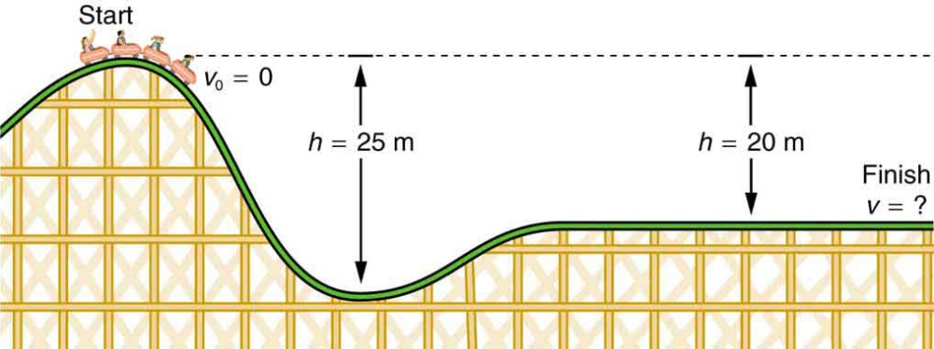

h₂
h₁

- If h₁ = 35 m and h₂ = 15 m and the mass of the roller coaster is 425 kg, what is the initial Potential Energy of the roller coaster at the start?

- What is the Kinetic Energy at the bottom of the hill?

- What is the velocity of the roller coaster at the bottom of the hill?

- What is the velocity of the roller coaster at the finish line?

