Handout One

The “Tool Kit” for solving series circuit problems:
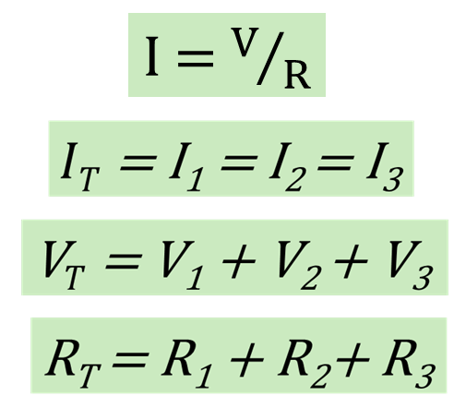

Summary of the step-by-step method of problem solving:

1. Write down what the problem is asking for.
2. Write the formula(s) needed to solve for the value(s) that will solve the problem from step one.
3. If the values needed for the formula are given, plug them into the equation and solve. If the values needed are not given, use one of the above “tools” to find a formula to give what is needed.
4. Repeat step three as necessary until you are finally able to calculate a value that leads to a solution. This process results in a sequence of problems that need to be solved in order.
5. Once you are able to solve for a value, plug that value into the previously developed formula.
6. Work your way back through the steps of the process developed in steps three and four writing down each formula and solution.
7. Highlight or circle the answer to the problem from step one.

Handout Two – Circuit Example Two
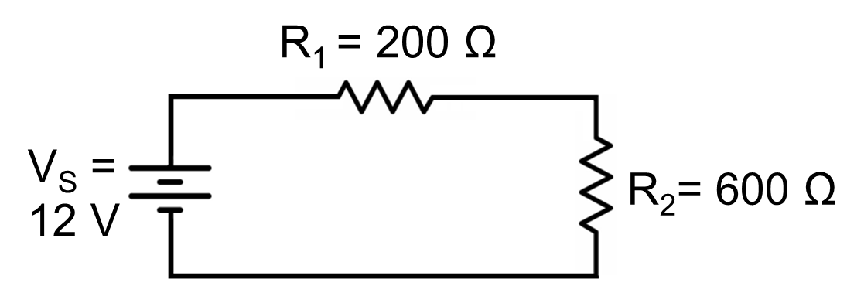

Solve for the voltage drops across R₁ and R₂

1. Write the equations for V_{R1} and V_{R2}
V_{R1} = I₁ • R₁ V_{R2} = I₂ • R₂
2. To use these equations to solve for voltage we need current. Write the equation for current
$$I= \frac{V}{R}$$
$V/R$

3. Looking for known values in this equation, we have V_{T}, we need R_{T}
R_{T} = R₁ + R₂ = 200 Ω + 600 Ω = 800 Ω
4. Substitute this into the formula from step two
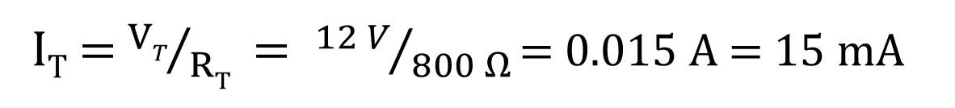

I_{T} = I₁ = I₂ = 15 mA
5. Now solve for voltage drops from step one
V_{R1} = I₁ • R₁ = 15 mA • 200 Ω = 3 V
V_{R2} = I₂ • R₂ = 15 mA • 600 Ω = 9 V

Handout Three – Sample problems with two resistors
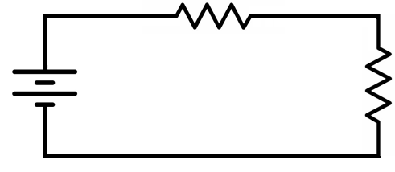
V_{S}
R₁
R₂

- V_{S} = 16 V, R₁ = 330 Ω, R₂ = 470 Ω Solve for I_{T}.

- b. Solve the above problem for V₁ and V₂

2. V_{S} = 15 V, R₁ = 2.7 kΩ, R₂ = 6 kΩ Solve for I_{T}.

2 b. Solve the above problem for V₁ and V₂

3. V_{S} = 9 V, R₁ = 15 kΩ, R₂ = 8.6 kΩ Solve for I_{T}.

3 b. Solve the above problem for V₁ and V₂

4. V_{S} = 72.4 V, R₁ = 631.41 kΩ, R₂ = 1.42 MΩ. Solve for I_{T}.

4 b. Solve the above problem for V₁ and V₂

5. I_{T} = 25 mA, R₁ = 2 kΩ, R₂ = 3 kΩ Solve for V_{s}
6. I_{T} = 3.33 mA, R₁ = 2.7 kΩ, R₂ = 1.5 kΩ Solve for V_{s}
7. I_{T} = 5.2 mA, R₁ = 1.2 kΩ, R₂ = 3.5 kΩ Solve for V_{s}
8. V_{S} = 5 V, R₁ = 2.8 kΩ, V₁ =1.8 V Solve for R₂
9. V_{S} = 12 V, R₁ = 6.8 kΩ, V₁ = 8 V Solve for R₂
10. V₁ = 9 V, R₁ = 3.3 kΩ, V₂ = 7.2 V Solve for R₂ and V_{S}
11. V_{S} = 22 V, R₁ = 5.6 kΩ, V₂ = 7.2 V Solve for R₂
12. V_{S} = 20 V, R₁ = 15 kΩ, V₂ = 7.2 V Solve for R₂
13. V₁ = 16.2 V, R₁ = 4.7 kΩ, V₂ = 7.2 V Solve for R₂ and V_{S}
Handout Four – Sample problems with three resistors
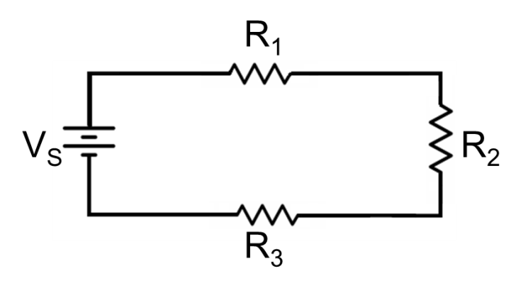

1. V_{S} = 15 V, R₁ = 330 Ω, R₂ = 470 Ω R₃ = 250 Ω Solve for V₁ , V₂ and V₃

2. V_{S} = 15 V, R₁ = 2.7 kΩ, R₂ = 4.5 kΩ R₃ = 6.2 kΩ Solve for V₁ , V₂, and V₃

3. V_{S} = 9 V, R₁ = 1.5 MΩ, R₂ = 860 kΩ R₃ = 660 kΩ Solve for V₁, V_{2,} and V₃

4. I_{T} = 8 mA, R₁ = 1.2 kΩ, R₂ = 3.3 kΩ, R₃ = 2 kΩ Solve for V_{s}

5. I_{T} = 3.16 µA, R₁ = 2.7 MΩ, R₂ = 1.5 MΩ R₃ = 860 kΩ Solve for V_{s}

6. V_{S} = 20 V, R₁ = 15 kΩ, V₂ = 6.4 V, V₃ = 7.8 V Solve for I_{T}

7. V_{S} = 12 V, R₁ = 6.8 kΩ, V₂= 4 V, V₃ = 5.4 V Solve for I₂

8. V₁ = 9 V, R₁ = 3 kΩ, V₂ = 7.2 V, V₃ = 5.8 V Solve for R₂ and R₃

9. V_{S} = 22 V, R₁ = 5.6 kΩ, V₂ = 7.2 V , R₃ = 8.4 kΩ, Solve for R₂

10. V_{S} = 5 V, R₁ = 4.8 kΩ, V₁ =1.6 V, R₃ = 6.4 kΩ, Solve for R₂

11. V₁ = 7.2 V, R₁ = 4.6 kΩ, V₂ = 2.8 V, V₃ = 1.2 V, Solve for R₂ and R₃

12. R_{T} = 900 Ω, P₁ = 48 mW, I₁ = 20 mA, R₂ = 100 Ω, Solve for R₃ and P₃

