Parallel Circuits Worksheet 1
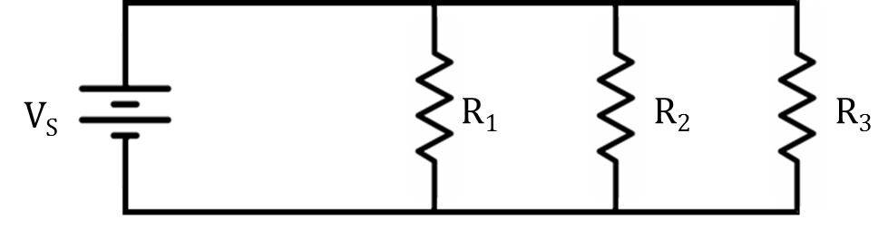

- R₁ = 500 Ω, R₂ = 200 Ω, calculate R_{T}.

- R₁ = 130 Ω, R₂ = 370 Ω, calculate R_{T}.

- R₁ = 500 Ω, R₂ = 400 Ω, R3 = 840 Ω, calculate R_{T}.

- R₁ = 370 Ω, R₂ = 620 Ω, R3 = 710 Ω, calculate R_{T}.

- R₁ = 124 Ω, R₂ = 167 Ω, R3 = 202 Ω, calculate R_{T}.

- R₁ = 550 Ω, R₂ = 270 Ω, R3 = 360 Ω, V_{S} = 14 V, calculate I_{T}.

- R₁ = 590 Ω, R₂ = 710 Ω, R3 = 770 Ω, V_{S} = 16 V, calculate I_{T}.

- R₁ = 170 Ω, R₂ = 270 Ω, R3 = 370 Ω, V_{S} = 22 V, calculate I_{T}.

- R₁ = 550 Ω, R₂ = 270 Ω, R3 = 360 Ω, V_{S} = 14 V, calculate I₁, I_{2,} and I_{3.}

- R₁ = 590 Ω, R₂ = 710 Ω, R3 = 770 Ω, V_{S} = 16 V, calculate I₁, I_{2,} and I_{3.}

- R₁ = 160 Ω, R₂ = 240 Ω, R3 = 360 Ω, V_{S} = 18 V, calculate I₁, I_{2,} and I_{3.}

