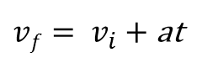
Physics Quiz
$$\vec{v}= \frac{Δs}{Δt}= \frac{s_{2} - s_{1}}{t_{2} - t_{1}}$$
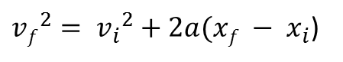

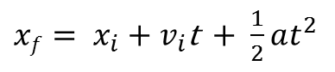
$\vec{a}=$= $\frac{v_{2} - v_{1}}{t_{2} - t_{1}}$
$$\frac{Δv}{Δt}$$

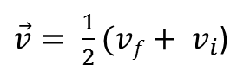

1. What is a graph?

2. Explain 2 things a graph does.

3. What is the simplest graph?

4. What is the difference between distance and displacement?

5. Describe a dot diagram.

0
Velocity

6. On the velocity-time graph on the right, Plot a
negative velocity with acceleration.

Using the information given, complete the other graphs.
5 m/s
30 m
Acceleration
Time
Time
Time
Distance
Velocity
0
0
0
10 m
20 m
5 s
10 s
15 s
20 s
25 s
5 s
10 s
15 s
20 s
25 s
5 s
10 s
15 s
20 s
25 s
-5 m/s
5 m/s²
-5 m/s²

Using the information given, complete the other graphs.
5 m/s
30 m
Acceleration
Time
Time
Time
Distance
Velocity
0
0
0
10 m
20 m
5 s
10 s
15 s
20 s
25 s
5 s
10 s
15 s
20 s
25 s
5 s
10 s
15 s
20 s
25 s
-5 m/s
5 m/s²
-5 m/s²

